Linux Assignment Report

1. 1. Install VirtualBox (Vagrant) on your laptop, spin up centos 7, and Ubuntu 18.04 Machine.   
   centos /7 and ubuntu/bionic64 are the Vagrant boxes that you need to download.

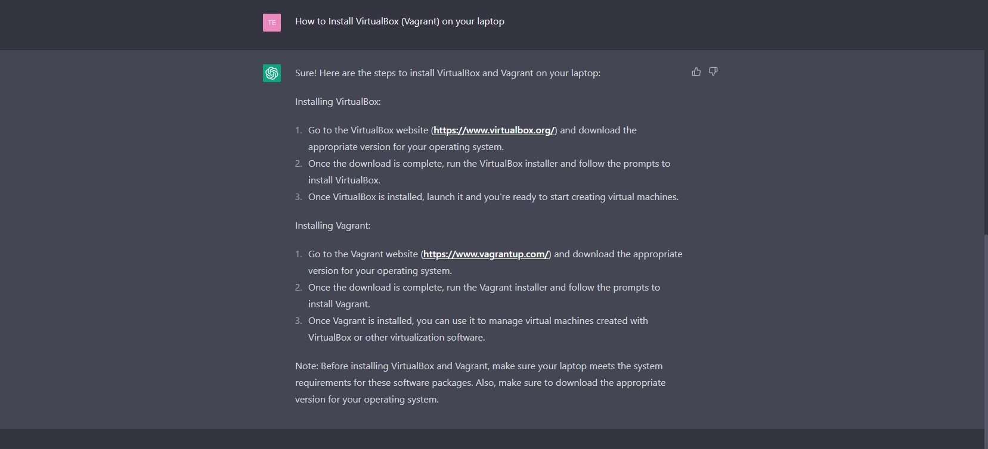

1. Find OS version, kernel version, uptime, memory, cores, and swap details of Linux machine.

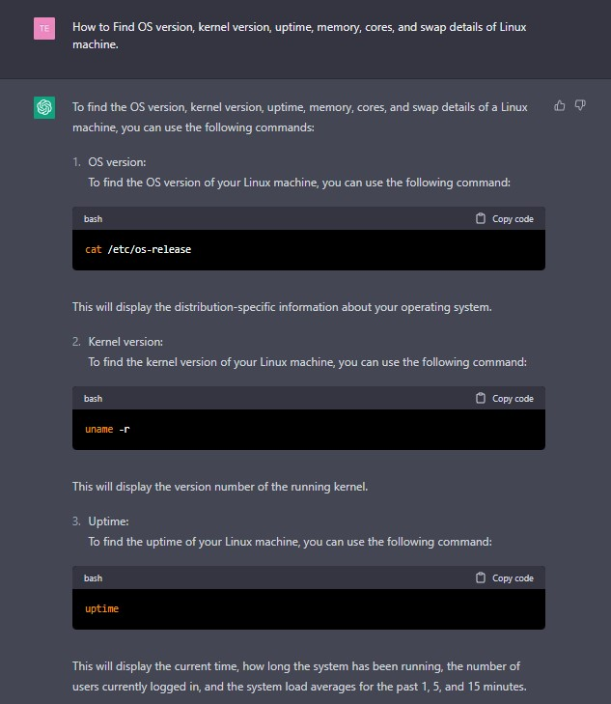

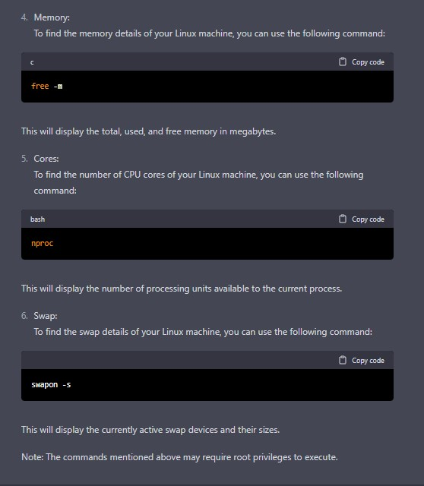

a. Be ready to explain what free & available memory is.



b. Release all cache memory & how do you manage the same in a prod env.

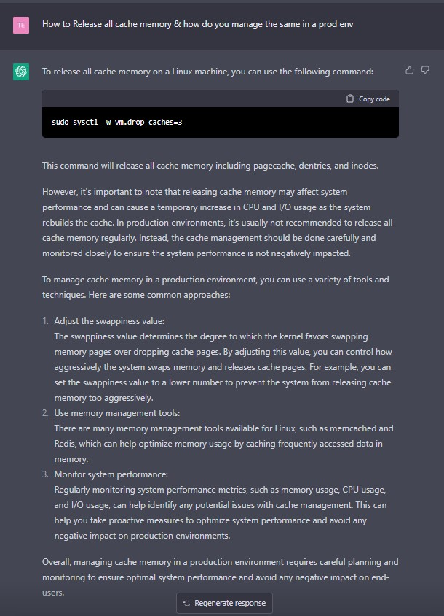

c. Increase the ulimit for the current user to 1028.

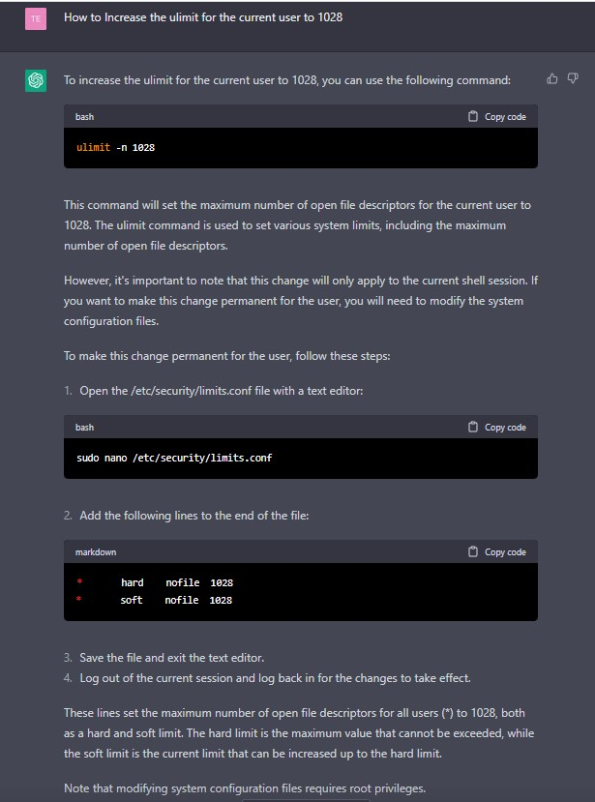

d. Change the timezone to IST

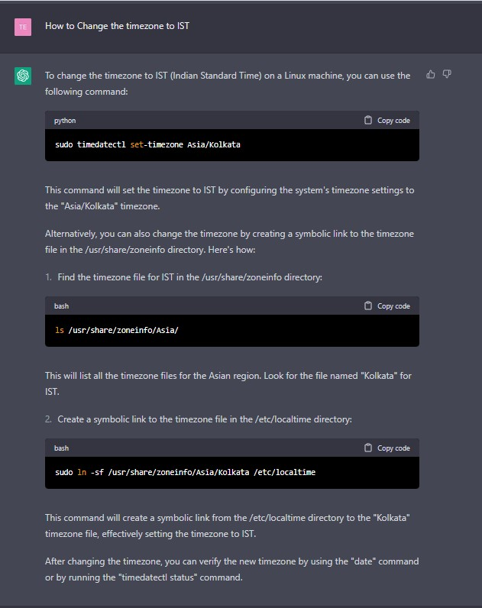

1. Install nginx

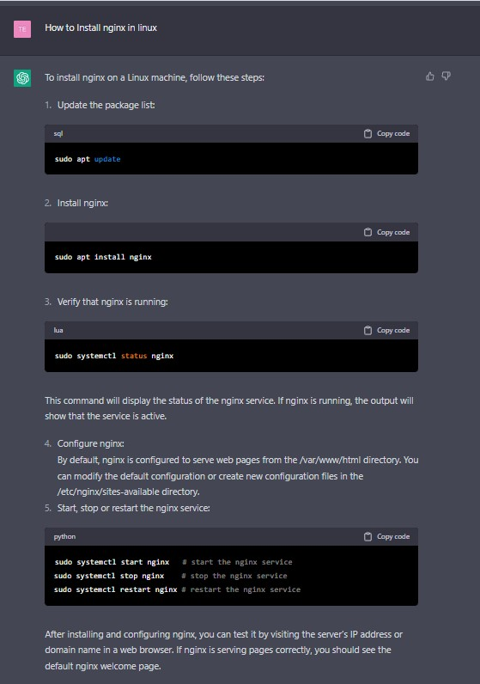

a. Configure the web server. Change the default location

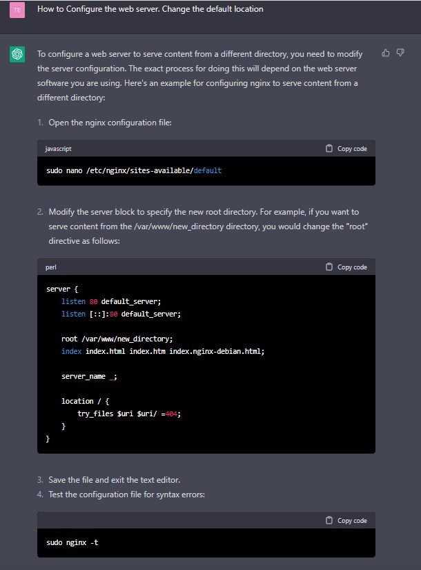

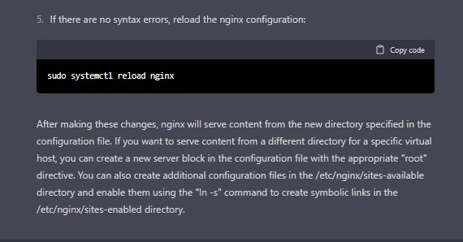

b. Route all the requests to port 8080.

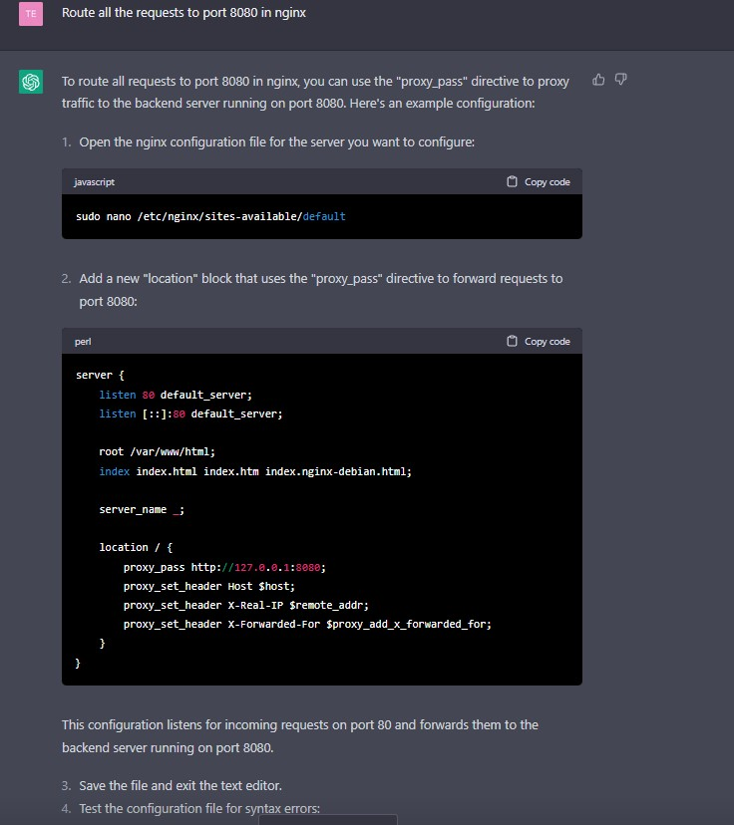

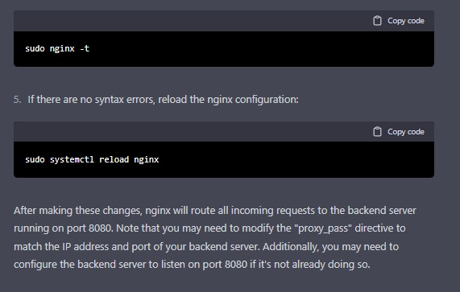

c. Configure the web server which shows files/directories and make them downloadable from the web page.

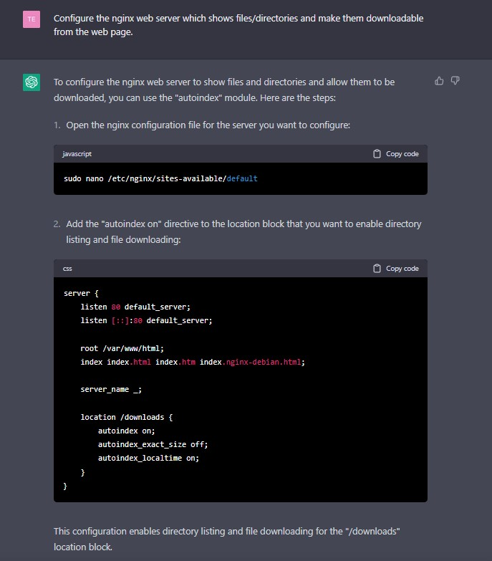

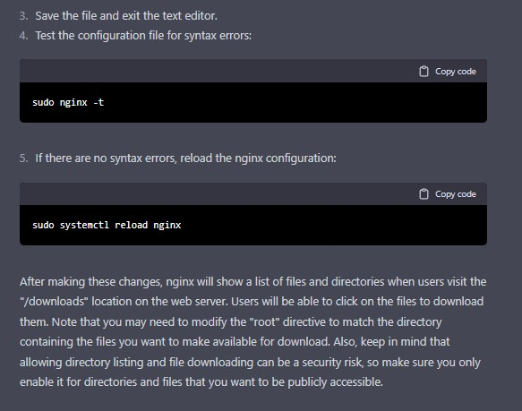

1. Create a job in crontab to create zip of system logs every last day of the month and keep only the last 30 days’ logs.

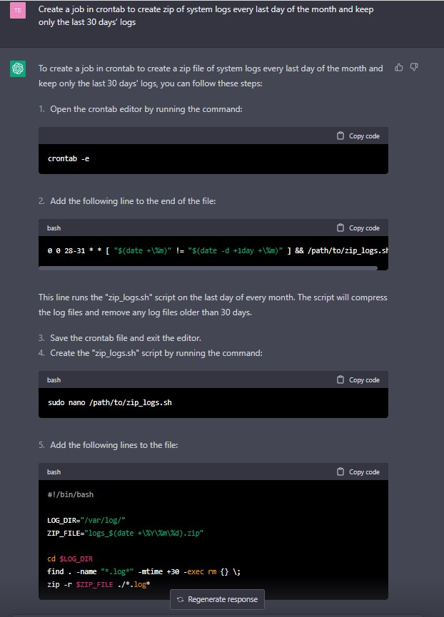

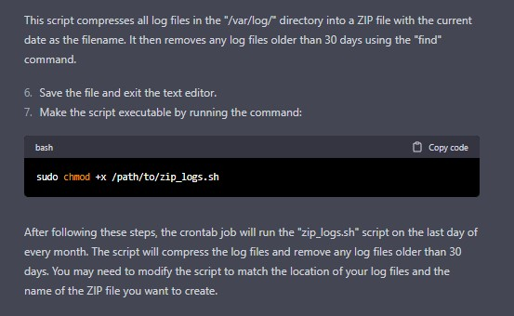

1. Date and Calendar should print whenever I open the terminal

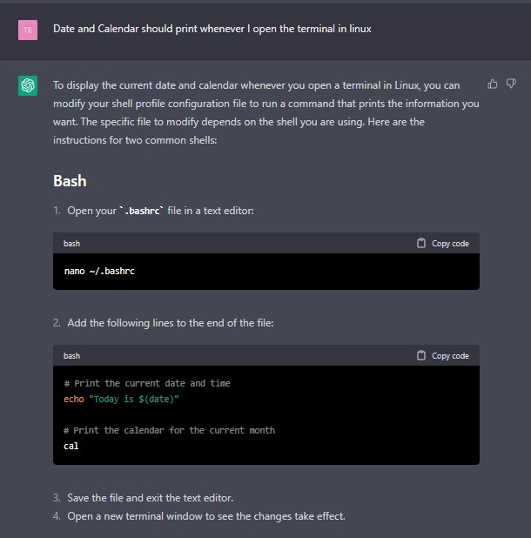

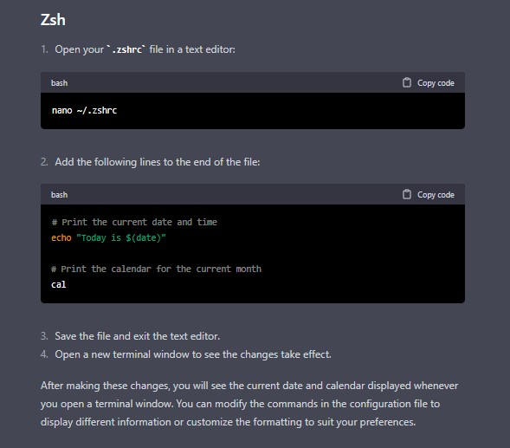

My solution:

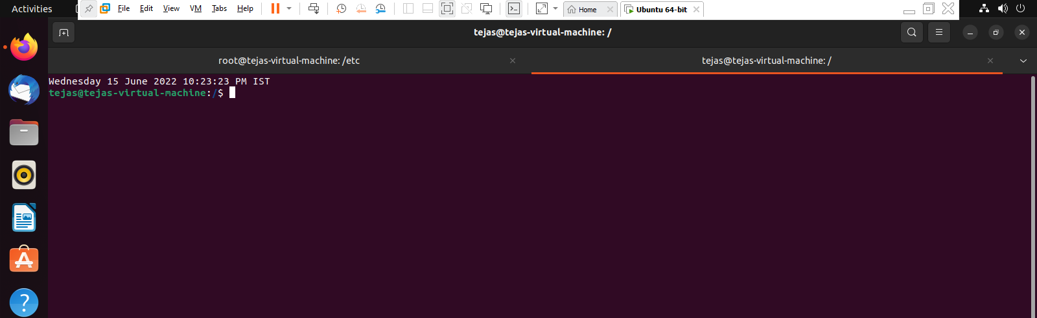

1. Create a User, and give it sudo privileges. But remove the power of rm.

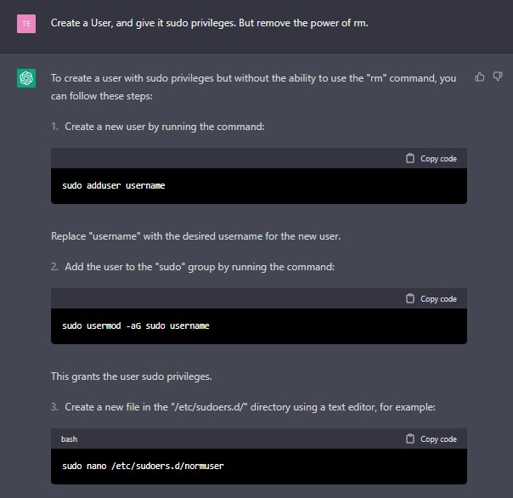

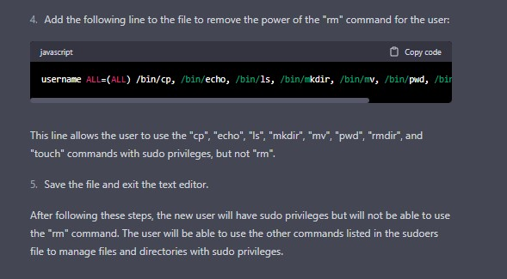

My solution:

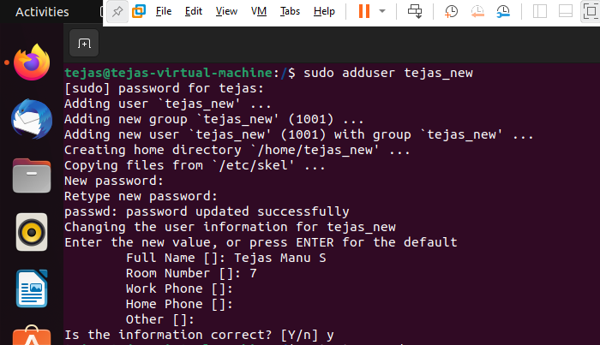

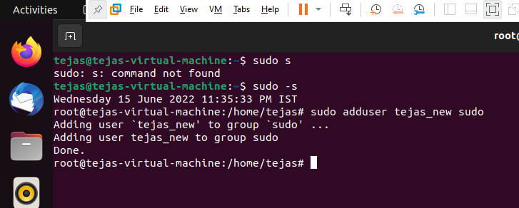

1. Change the default port number for RDP to 8339 and document on the same.

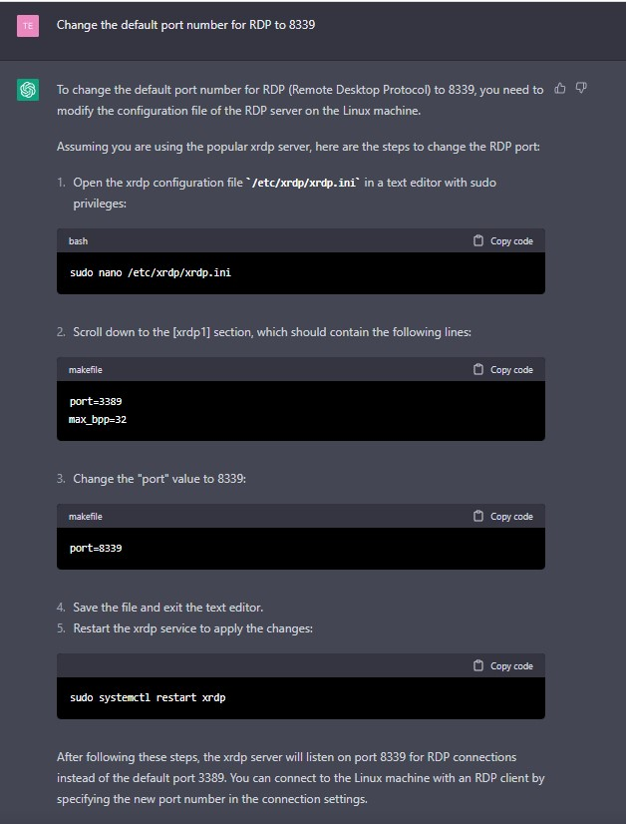

My solution:

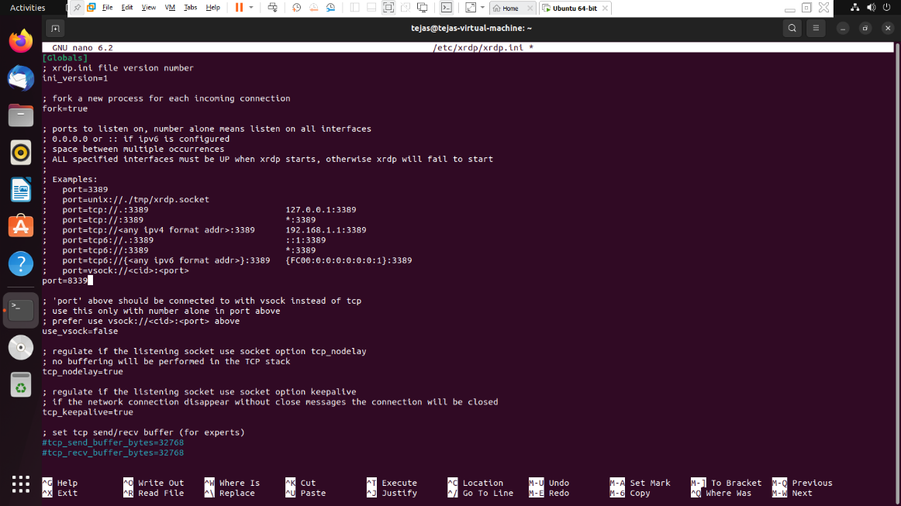

1. Create a script to take regular backup of the database(MySql & Postgres), say every day at 11PM.

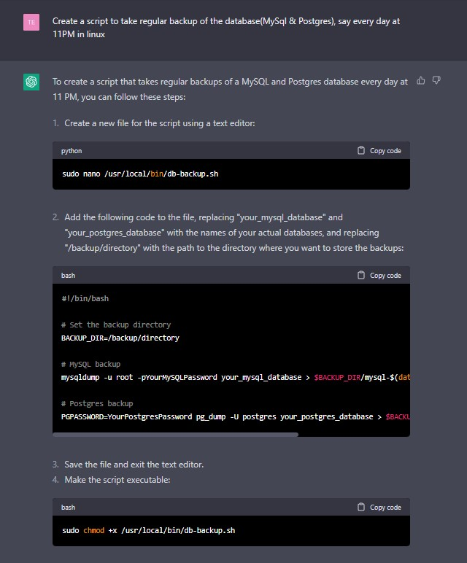

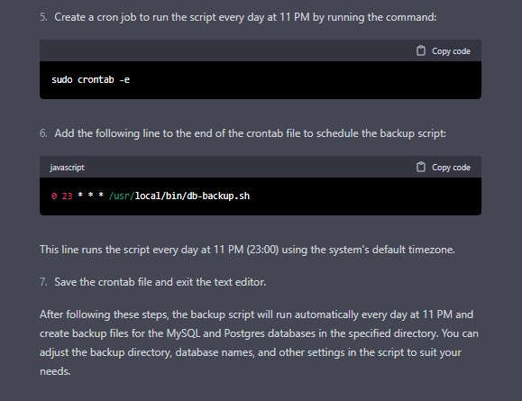

1. Create a file that contains memory usage and the number of cpu in linux using the sed command.

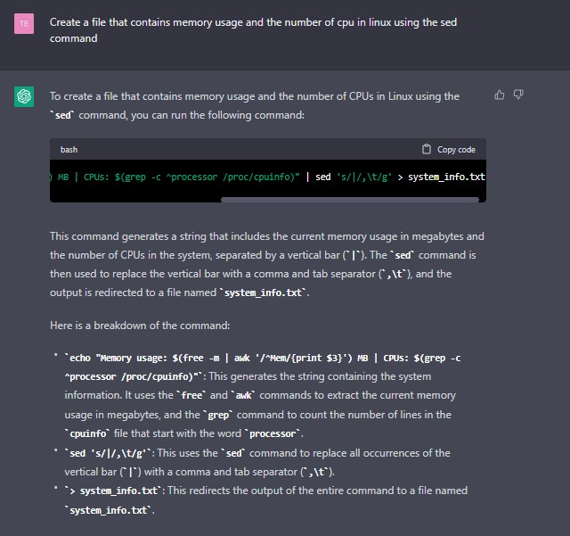

My solution:

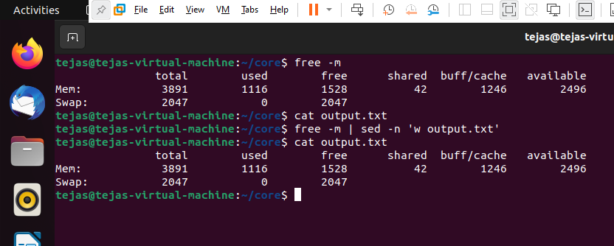

1. Find a file with all command line history and Delete the Complete Command line History.



1. Detecting which process has the highest priority in the system. Now find out what its purpose is.

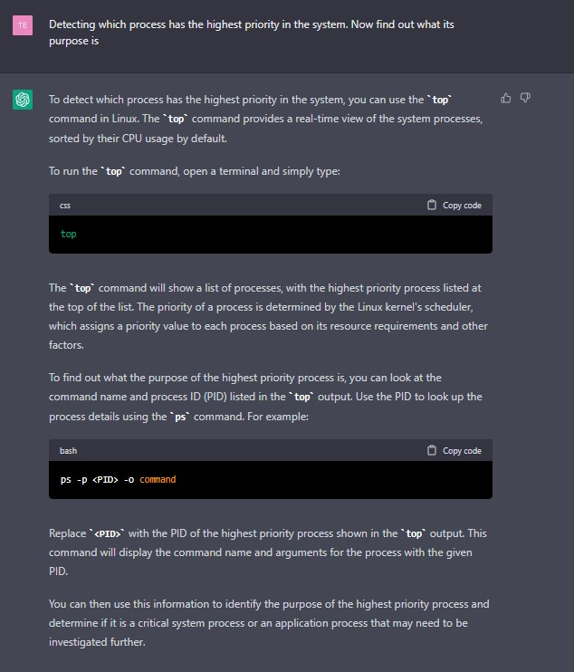

1. Perform the below tasks on the firewall using iptables:  
   a. Block outgoing connections on port 80

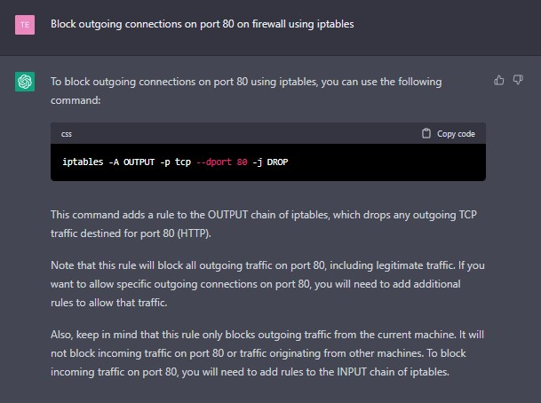

My solution:

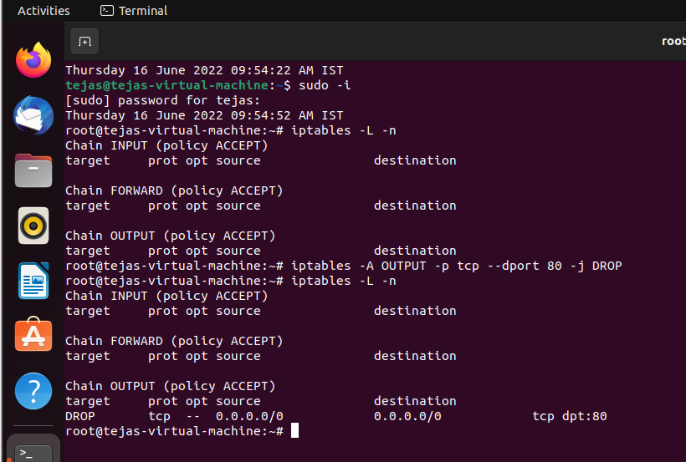

b. Allow incoming connections on port 3306

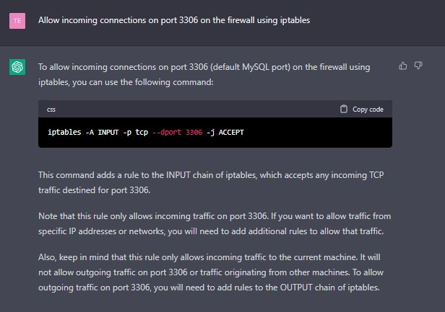

My solution:



c. Allow both incoming and connections on port 80, 443 and 22

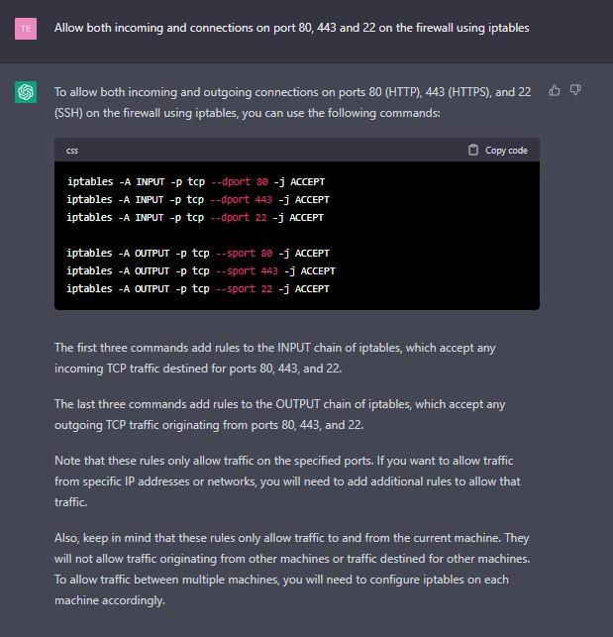

My solution:

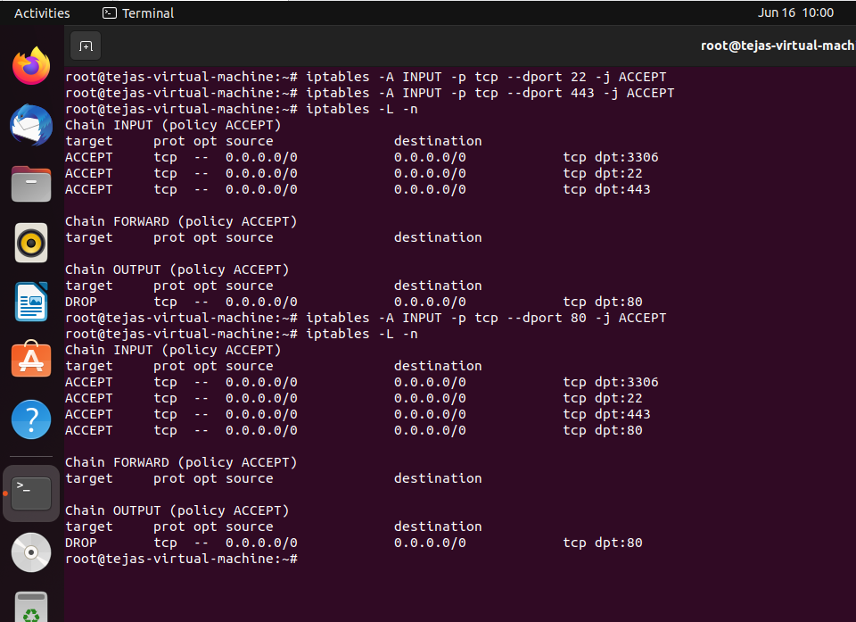

d. Block Facebook on Iptable firewall

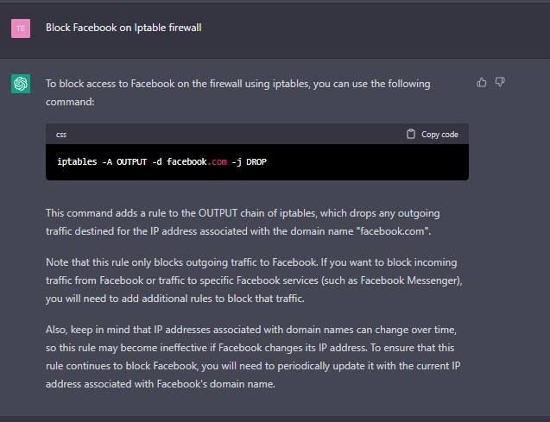

My solution:

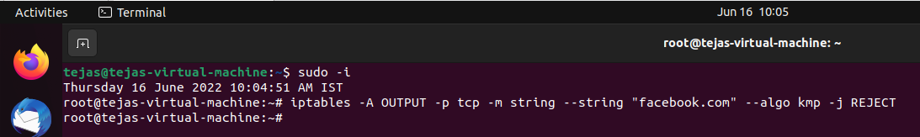

1. Get Tasks, Threads, Running Processes, Load Average and Uptime using htop command.

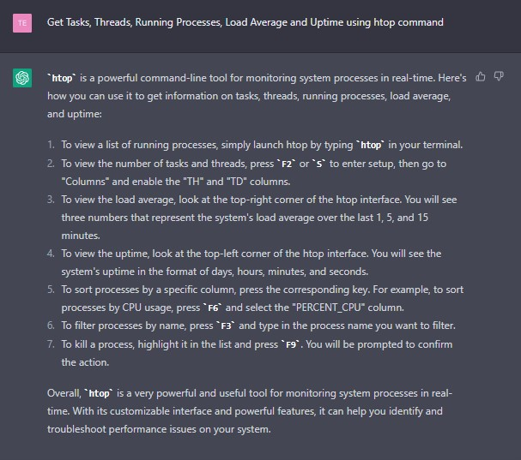

1. Using netstat command, perform the below operations  
   a. To display all the active list of listening port connections.

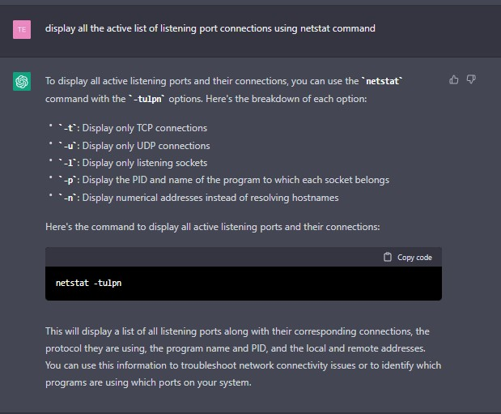

My solution:

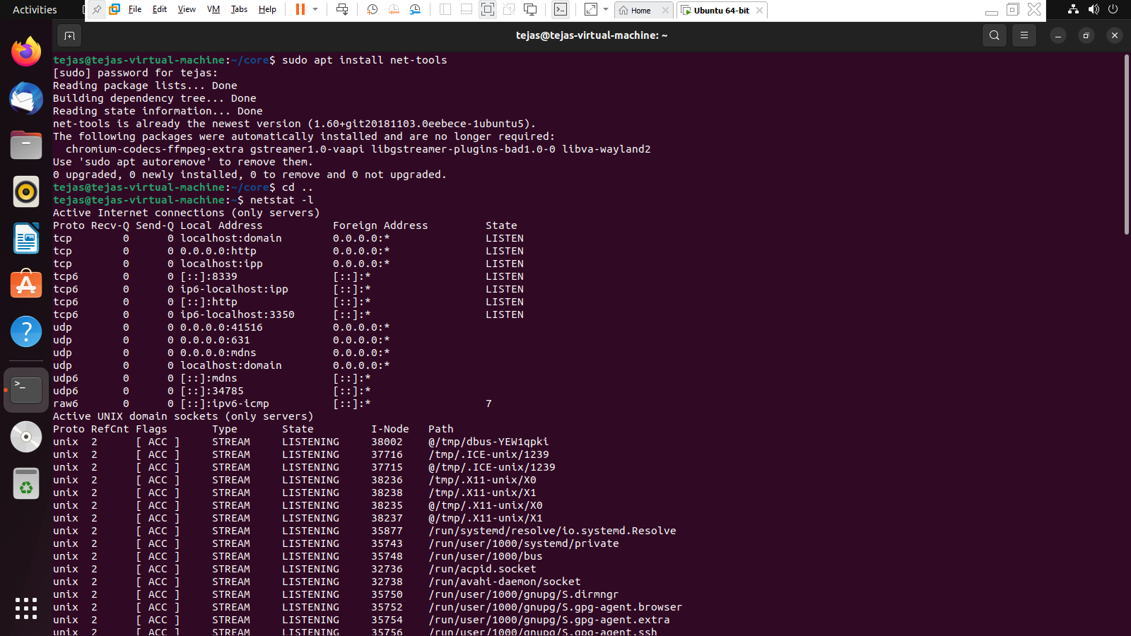

b. To display only the active listening TCP ports.

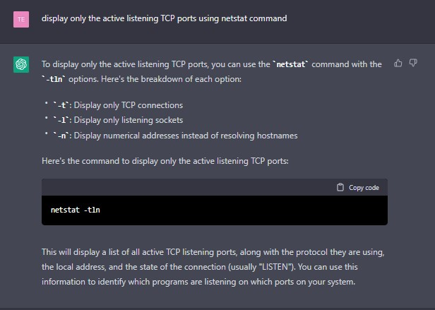

My solution:

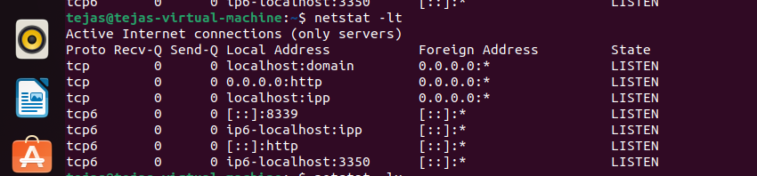

c. Netstat command in Linux will help to display all the active UNIX port connections.

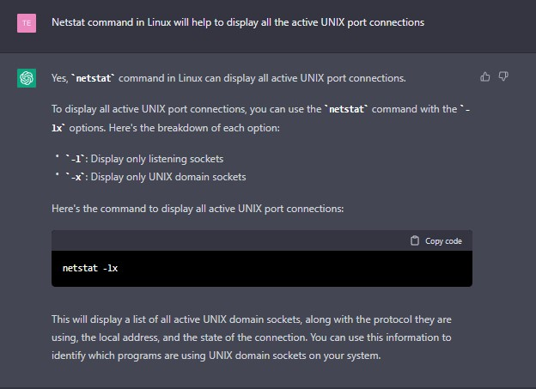

My solution:

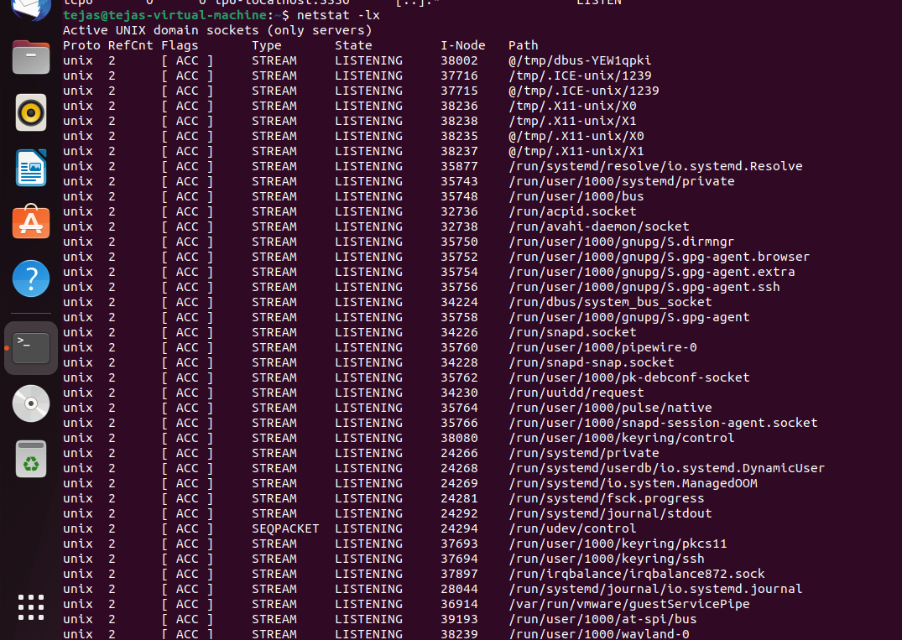

***********************Shell Scripting *******************************

1. Write a script five_dirs.sh that does these tasks:  
   a. make a directory five.  
   b. make five subdirectories five/dir1 through five/dir5.  
   c. in each subdirectory, make four files, file1 through file4, such that file1 has one line containing the digit 1, file2 has two lines, each containing the digit 2, ..., and file4 has four lines, each containing the digit 4

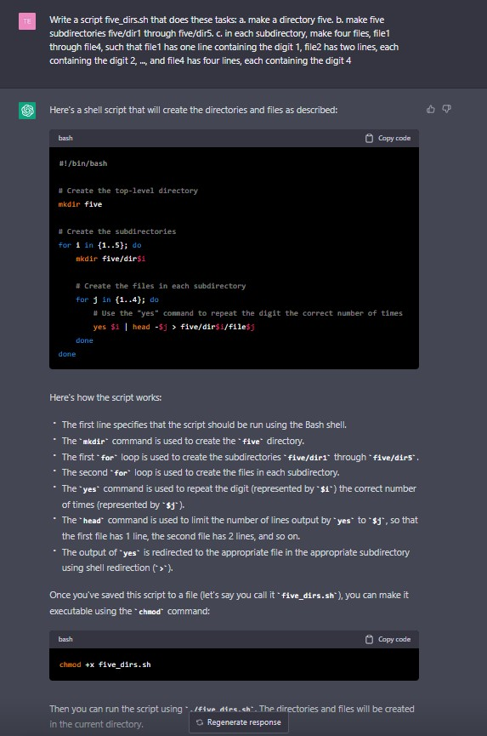

My solution:

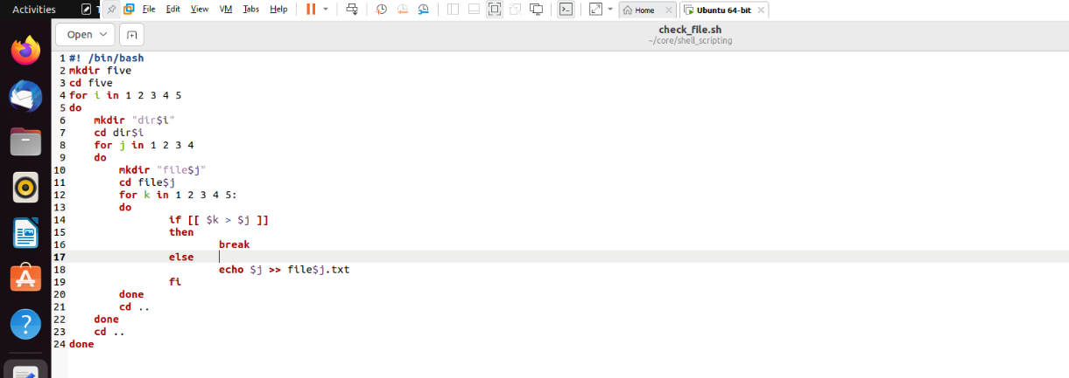

1. Get user input of file path and evaluate the status of a file ( Whether it is writable, executable/searchable, readable, directory etc)

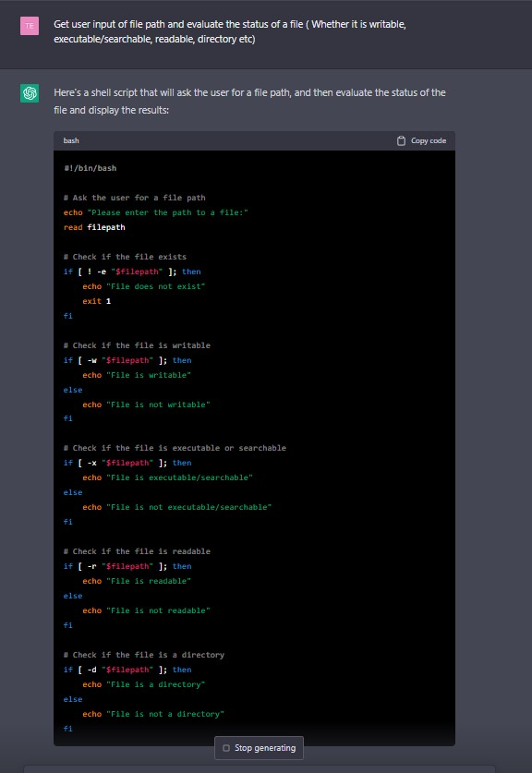

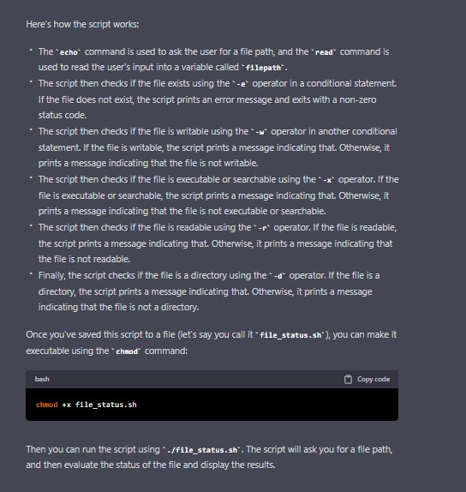

1. Write a program to calculate overtime pay of employees. Overtime is paid at the rate of Rs. 12.00 per hour for every hour worked above 40 hours. Assume that employees do not work for fractional part of an hour.

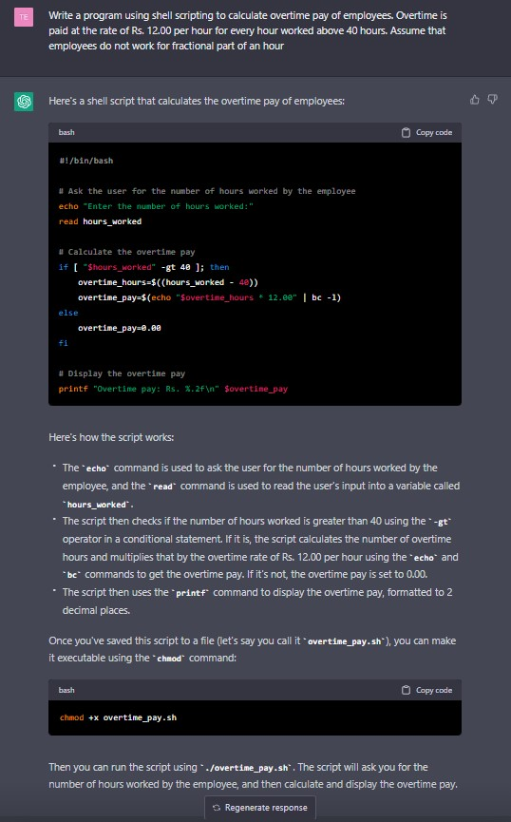

My solution:

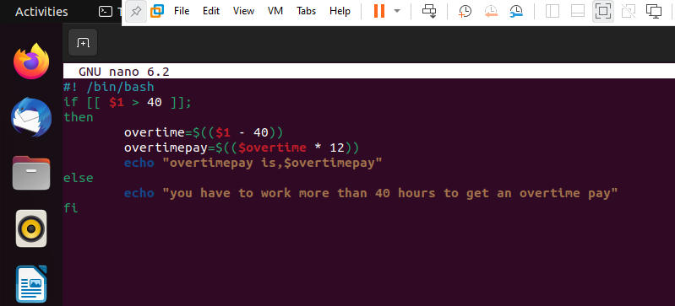

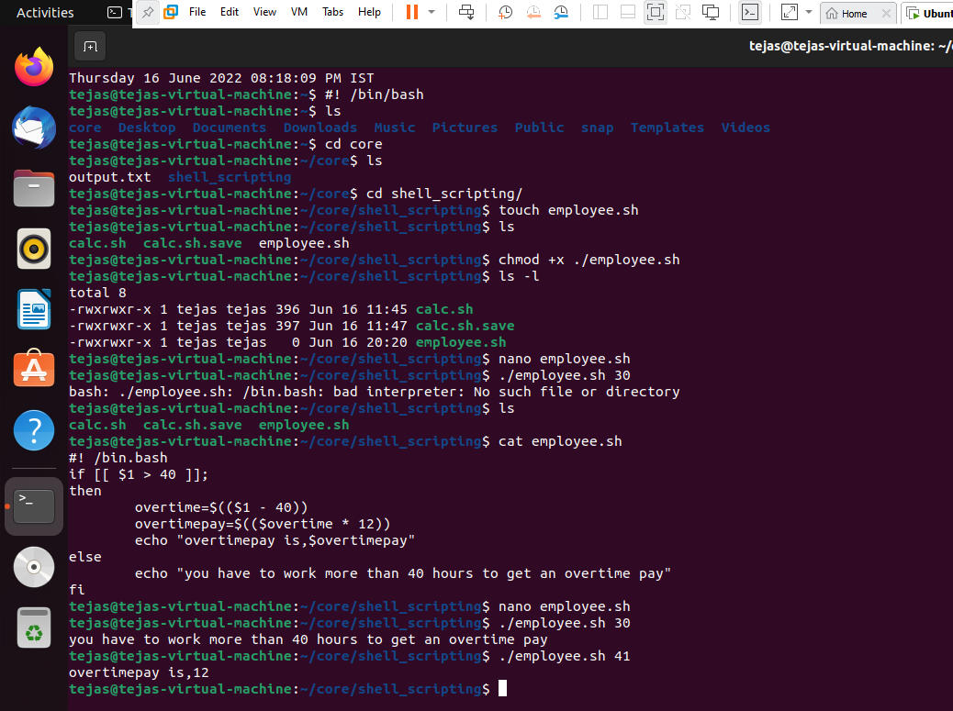

1. Write a script that every time, I reboot there should be an email sent to Admin that takes dump of last 100 message of dmesg in zipped form.

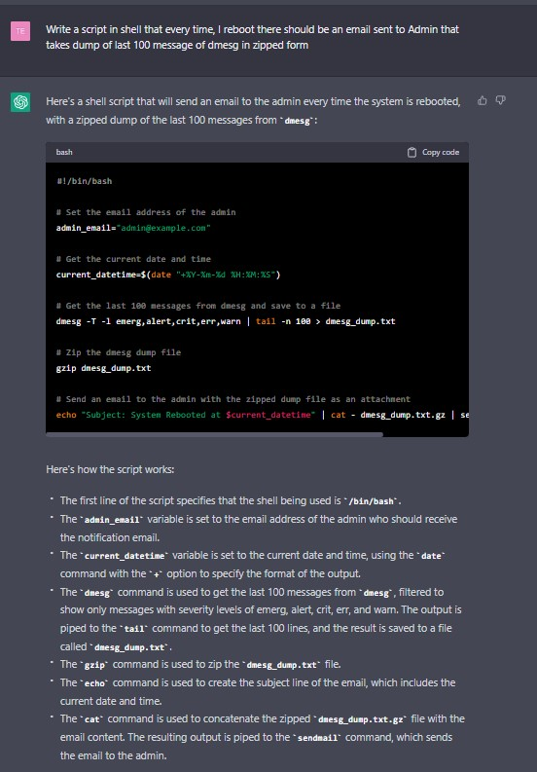

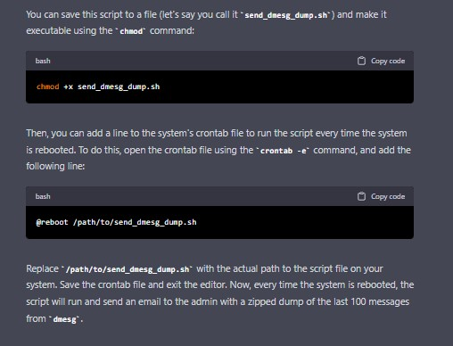

1. Write a shell script that will take an input file and remove identical lines (or duplicate lines from the file).

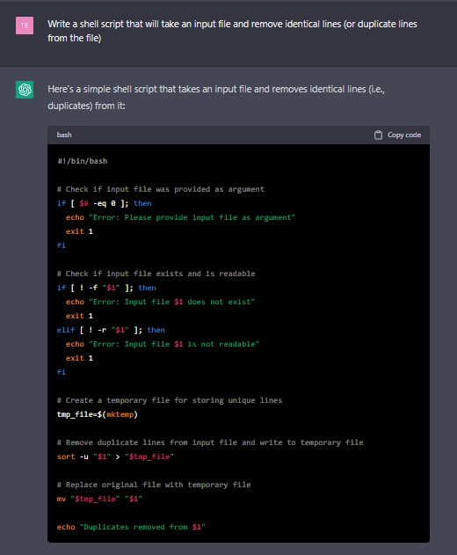

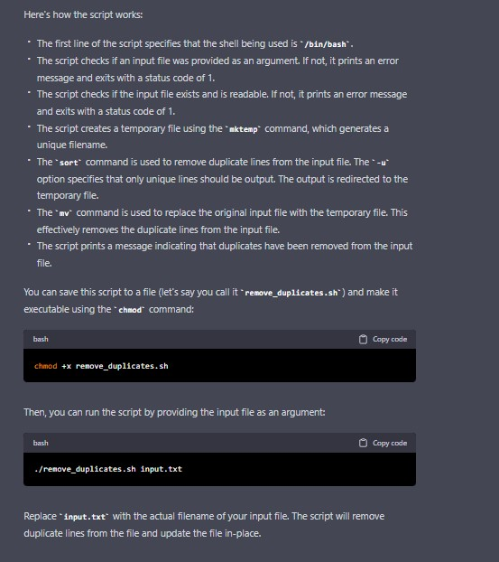

My Solution:

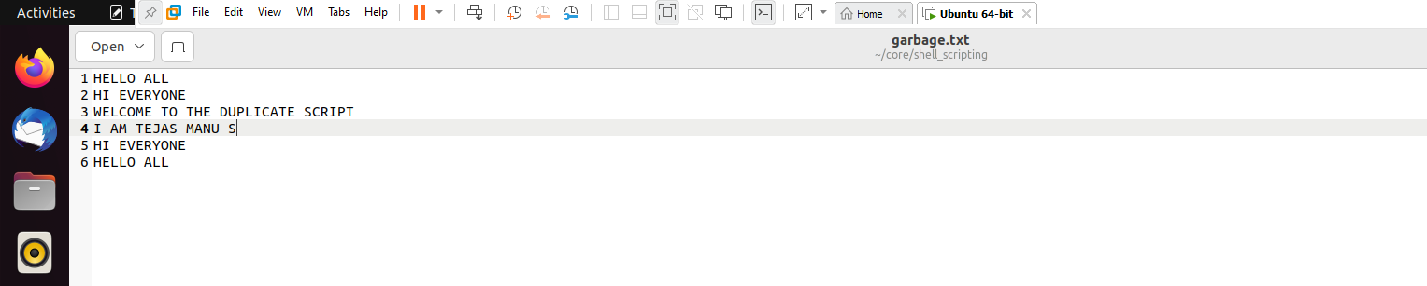

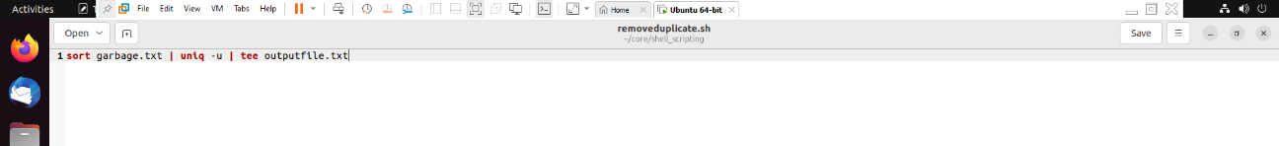

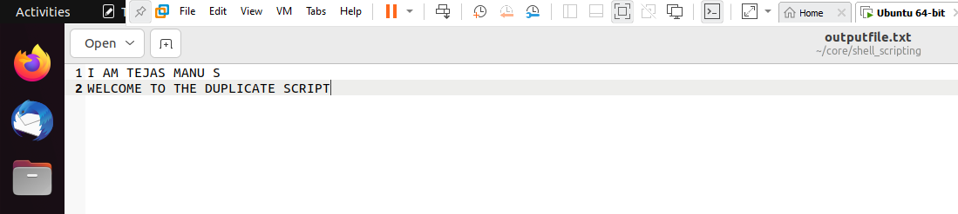

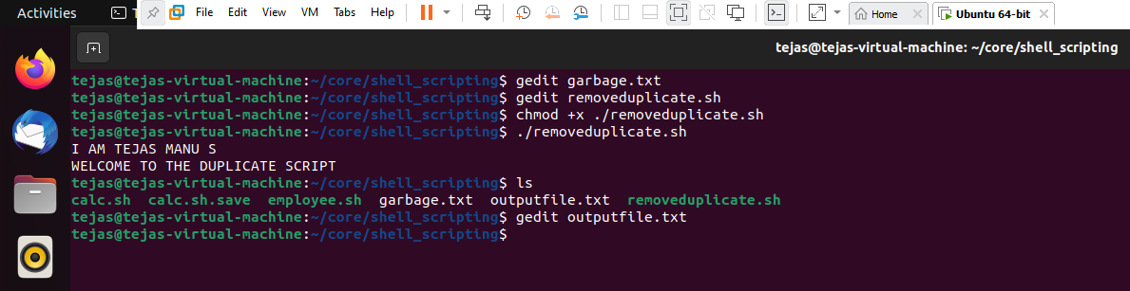

1. Create a bash file to assess password strength.   
   a. Minimum Characters should be 6.   
   b. Should Contain both alphabet and number.   
   c. Should Include both the small and capital case letters.   
   d. If the password doesn’t comply with any of the above conditions, then the script should report it as a <Weak Password>

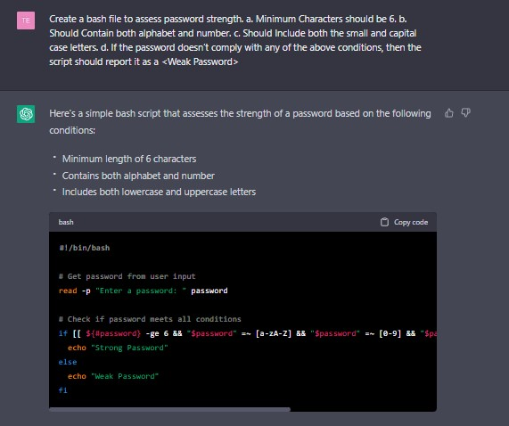

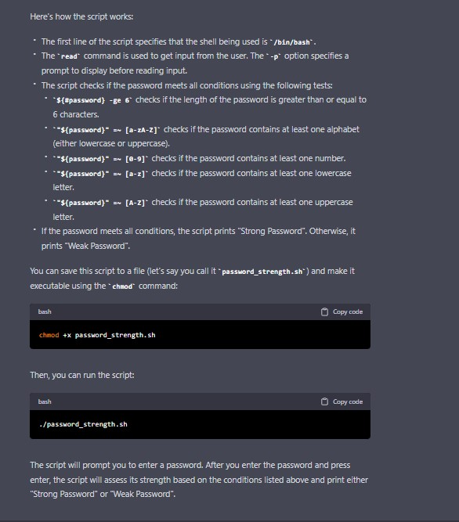

My solution:

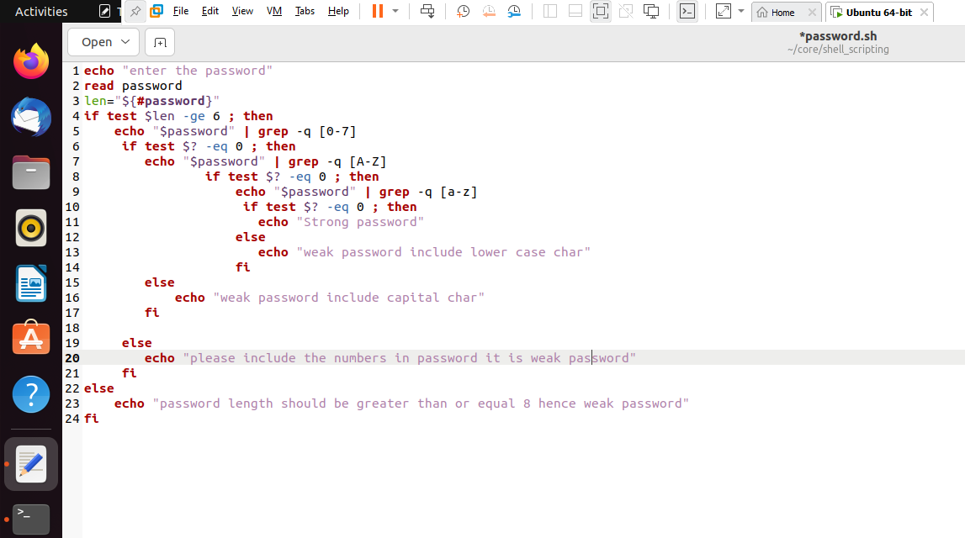

1. Write a shell script to accept two integer values for two variables Perform following actions -  
   Create the following functions for the same -

|  |  |
| --- | --- |
| Operation | Function |
| Addition | add(a,b) |
| Subtraction | subtract(a,b) |
| Division | divide(a,b) |
| Multiplication | multiply(a,b) |

a. Addition   
b. Multiplication   
c. Division  
d. Subtraction   
e. If the input is invalid it should return the input is invalid with a comment.

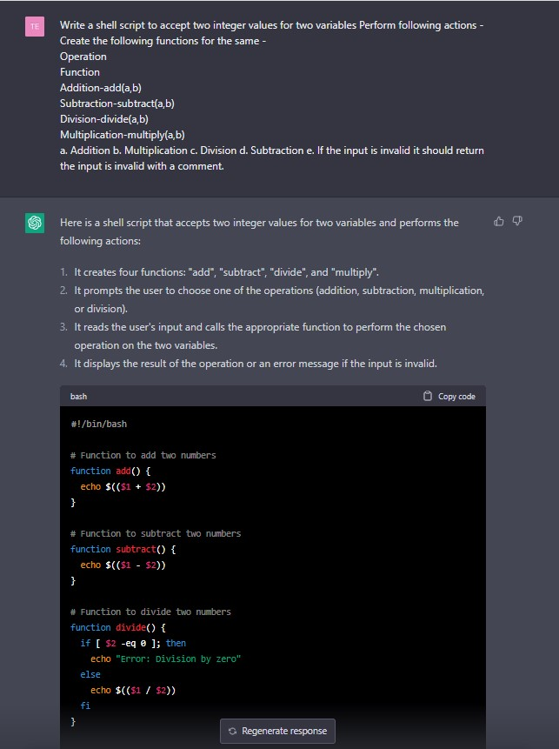

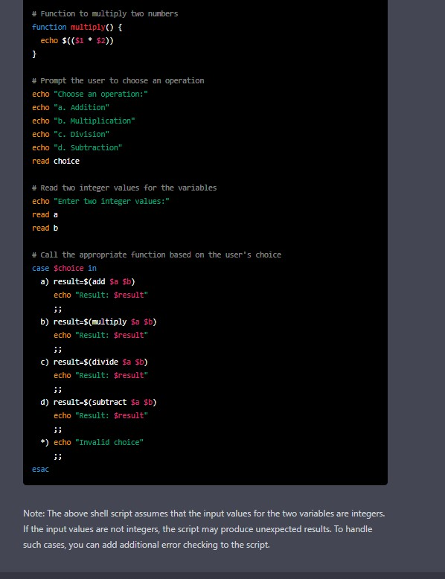

My solution:

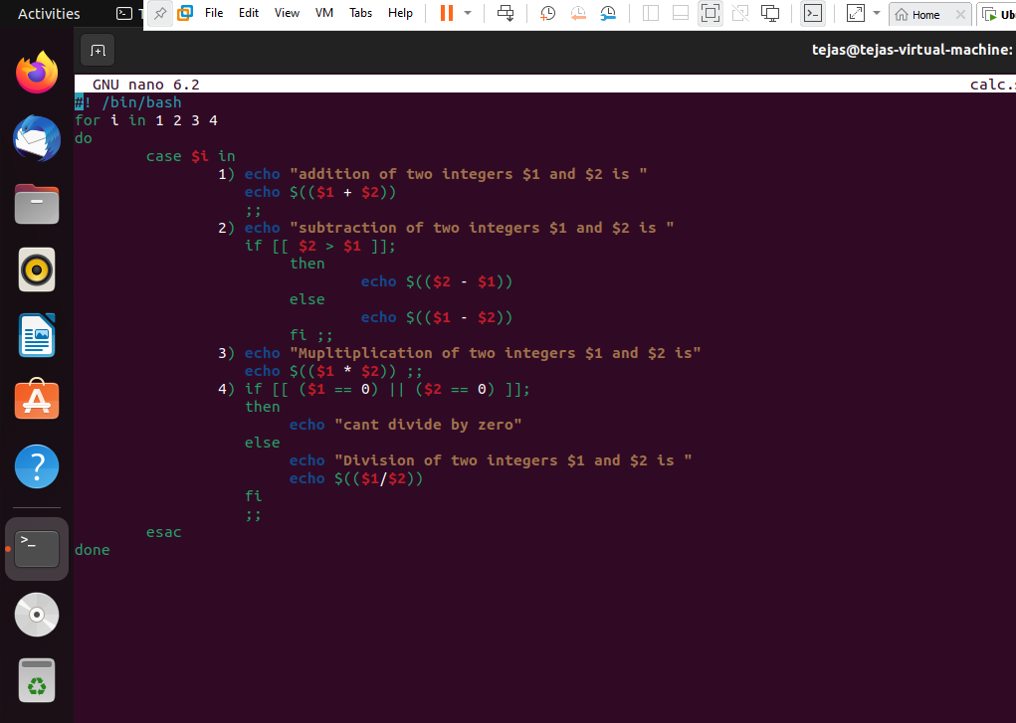

1. Write a shell script that takes a directory as an input and counts the total number of different types of files and directories present in the input directory .Example -

input_dir/

-- dir1/

-- -- file1.txt

-- -- file1.js

-- -- file2.md

-- -- dir2/

-- -- -- -- file2.txt

-- -- -- -- file2.ts

-- file.md

-- file.sh  
expected Output -

Output

txt: 2

js: 1

md: 2

ts: 1

sh: 1

directories: 2

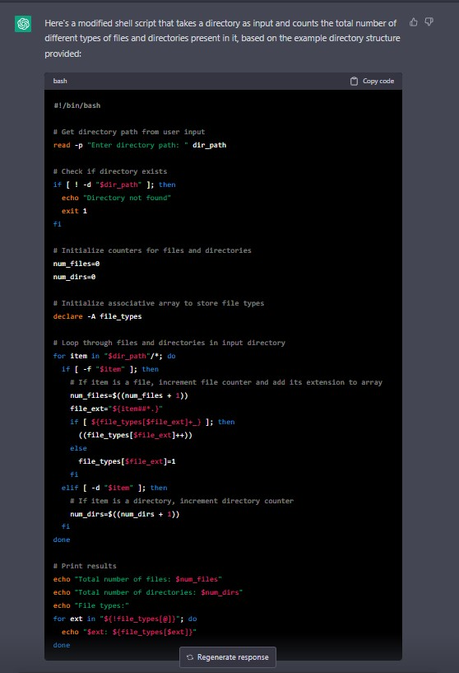

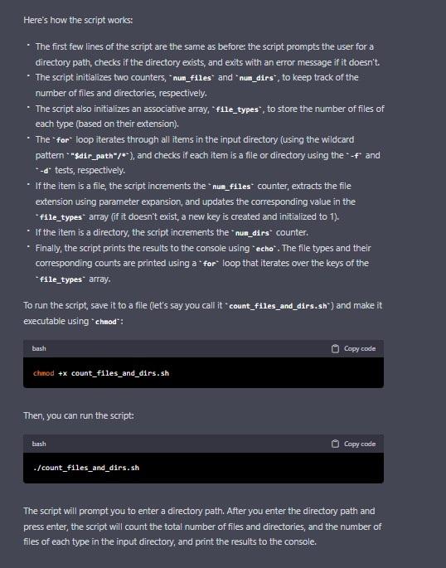

1. In log file which looks like this:  
   [status code] IP /endpoint timestamp_utc response_time_s message  
   - give avg response times of all /abc calls  
   - give all endpoints with more than 5 4xx errors  
   - give Ip with most API hits

[200] 172.3.4.2 /abc xyz 0.1 OK  
[200] 172.3.43.5 /efg xyz 0.1 OK  
[200] 172.123.4.6 /qwe xyz 0.1 OK  
[200] 172.3.4.24 /abc xyz 0.2 OK  
[400] 172.3.44.2 /abc xyz 0.3 OK  
[400] 172.3.123.9 /qwc xyz 0.3 OK  
[404] 172.33.4.1 /trc xyz 0.3 OK

example - <shell script file> <file name> /<endpoint>

./log_analysis.sh <filename> /abc -> 0.2